ECA5604- 5g/6g communication
Slot A
M.Pregna
192412350

Experiment 1: Simulation of FDMA in MATLAB
Aim: To simulate a Frequency Division Multiple Access (FDMA) system using MATLAB
and analyze its communication performance in terms of channel bandwidth, data rate, and
signal-to-noise ratio (SNR).
Objective 1:
To simulate an FDMA system by allocating individual frequency channels to multiple users
and determine the channel bandwidth assigned to each user.
Output Parameter: Channel Bandwidth (kHz)
Code:
clc; clear; close all;
fs=1000; t=0:1/fs:1;
TBW=600; Users=3;
CBW=TBW/Users;
fc=[100 300 500];
m=sin(2*pi*10*t);
s1=m.*cos(2*pi*fc(1)*t);
s2=m.*cos(2*pi*fc(2)*t);
s3=m.*cos(2*pi*fc(3)*t);
subplot(2,1,1)
plot(t,s1,'r',t,s2,'g',t,s3,'b'),grid on
title('FDMA Channel Allocation'),xlabel('Time (s)'),ylabel('Amplitude')
subplot(2,1,2)
bar(1:Users,CBW*ones(1,Users)),grid on
xlabel('Users'),ylabel('Channel Bandwidth (kHz)'),title('Channel Bandwidth per User')

output:
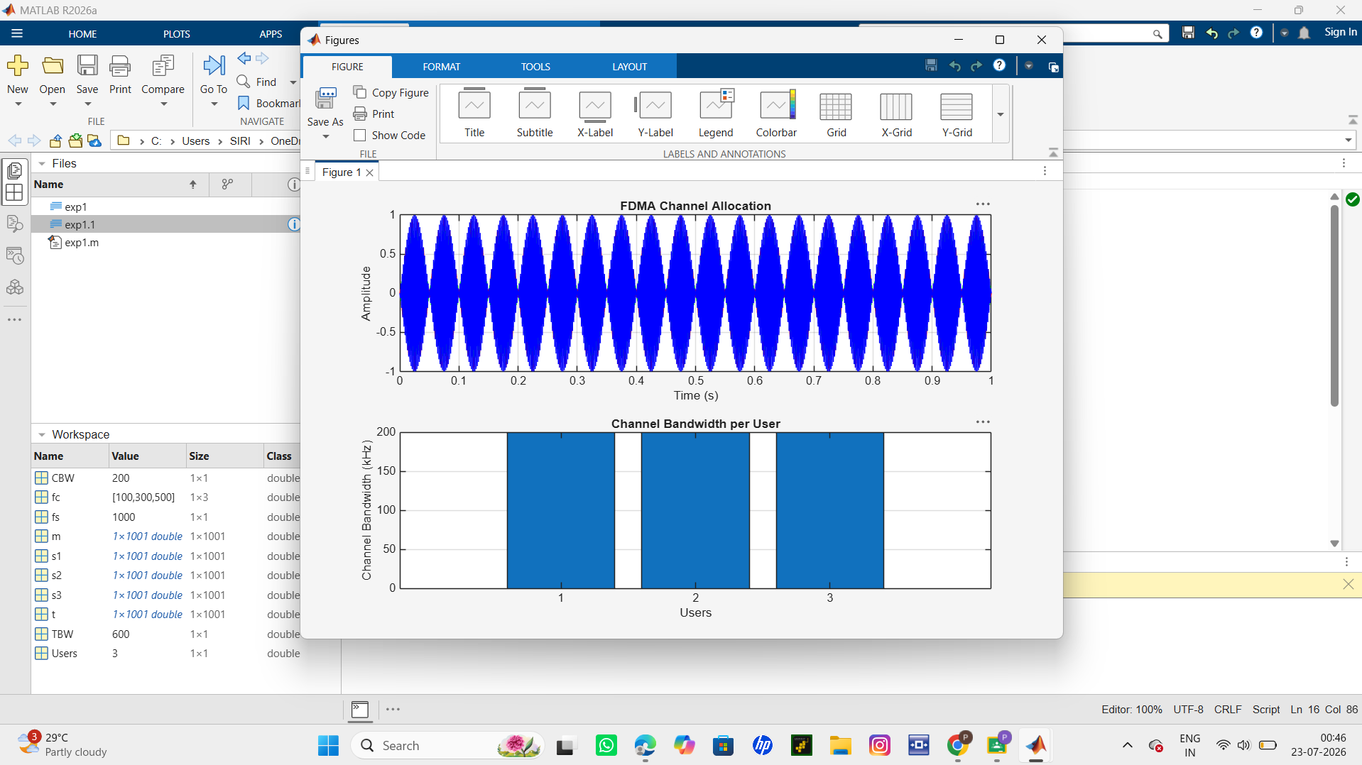
Output Graph 1: FDMA Channel Allocation
• Displays three users transmitting on different carrier frequencies (100 kHz, 300 kHz,
and 500 kHz).
• Demonstrates that each user occupies a separate frequency channel.
Output Graph 2: Channel Bandwidth Allocation
• Shows a bar graph of the bandwidth allocated to each user.
• Each user is assigned 200 kHz, confirming equal FDMA channel allocation.

Objective 2:
To calculate the data rate achieved by each user in the FDMA system based on the allocated
channel bandwidth.
Output Parameter: Data Rate (kbps)
Code:
clc; clear; close all;
BW = 200; % Channel Bandwidth (kHz)
Users = 3;
M = 2; % BPSK Modulation
DataRate = BW*log2(M); % Data Rate (kbps)
Rate = DataRate*ones(1,Users);
disp(' User Data Rate (kbps)')
disp([(1:Users)' Rate'])
figure
bar(1:Users,Rate)
xlabel('Users')
ylabel('Data Rate (kbps)')
title('FDMA Data Rate for Each User')
grid on
output:
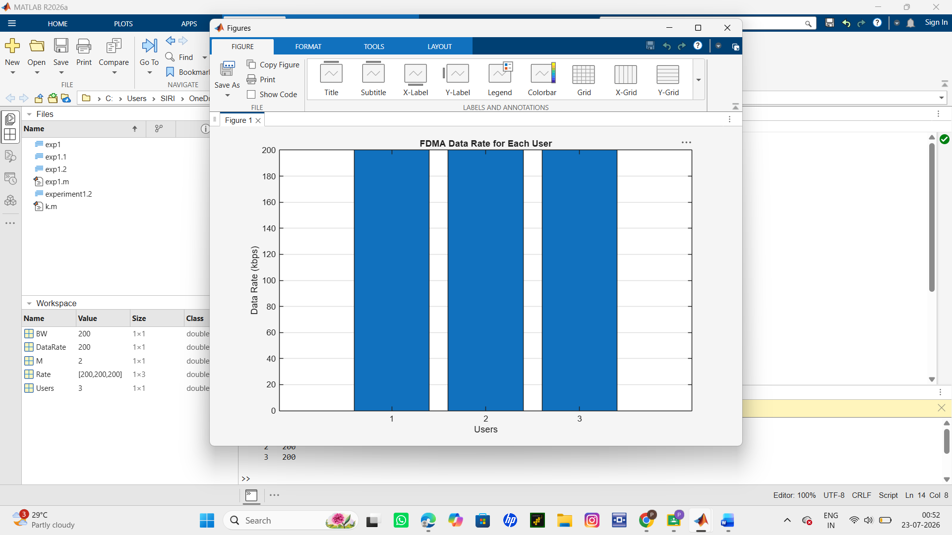
Result:
The graph shows that all FDMA users achieve an equal data rate of 200 kbps due to equal channel
bandwidth allocation. This confirms fair and interference-free data transmission among users.
Objective 3:
To evaluate the communication quality of the FDMA system by calculating the Signal-to-
Noise Ratio (SNR) for different users.
Output Parameter: Signal-to-Noise Ratio (SNR) (dB)
Code:
clc; clear; close all;
Ps = 1; % Signal Power (W)
Pn = [0.1 0.05 0.01]; % Noise Power (W)
Users = 1:3;
SNR = 10*log10(Ps./Pn); % SNR in dB
disp('User Noise Power(W) SNR(dB)')
disp([Users' Pn' SNR'])
figure
bar(Users,SNR)
xlabel('Users')
ylabel('SNR (dB)')
title('Signal-to-Noise Ratio of FDMA Users')
grid on
output:
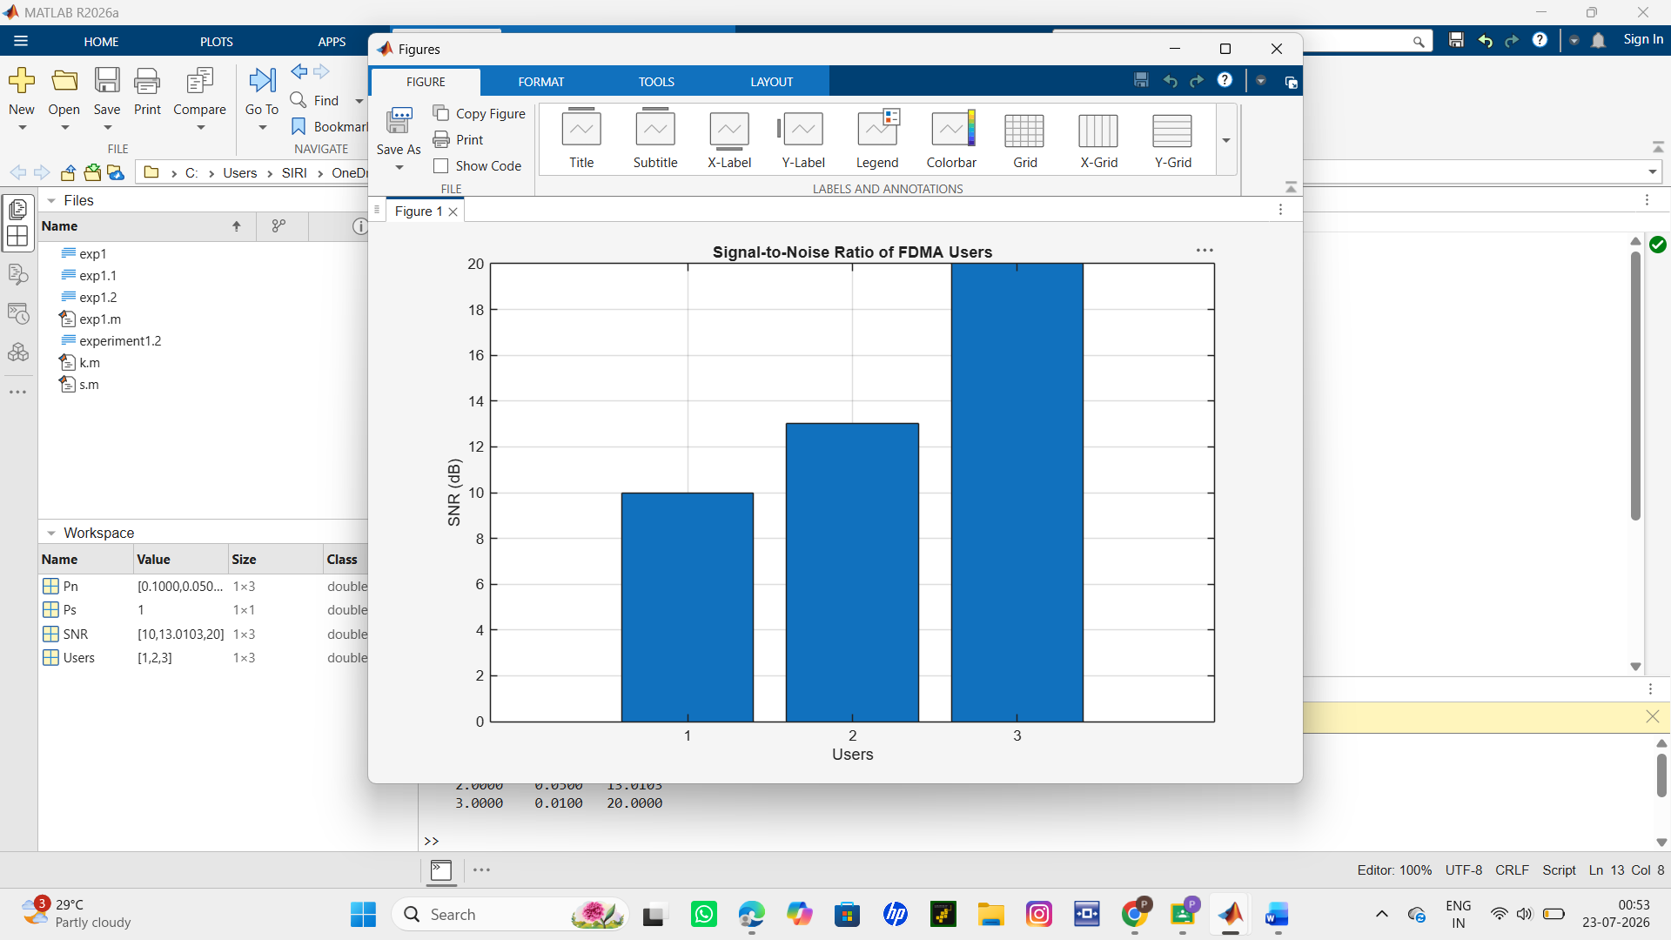
Result:

1. The FDMA system was successfully simulated by allocating separate frequency channels
to three users, and the channel bandwidth assigned to each user was determined.
2. The data rate achieved by each user was successfully calculated based on the allocated
channel bandwidth, demonstrating equal transmission capacity for all users.
3. The Signal-to-Noise Ratio (SNR) for different users was successfully evaluated,
showing that higher SNR values provide better communication quality and reliable data
transmission.

